The ProScan Series project takes shape from our customers’ desire to use measuring instruments capable of offering high reliability, precision and the possibility to acquire, with simplicity, any type of physical measurement for further processing.

Introduction
The instruments have been conceived for maximum user friendliness achieved through simple and effective menus; we have taken great care in offering nothing more and nothing else than what the user can effectively use.
During the design process, we have not only taken into consideration the high quality of these instruments, but also the simplicity in handling an heterogeneous mass of data by means of the “Galileo 2.1” program which allows the user to synchronize data from different acquisition units; for example using three “ProScan III k” units you can generate a single data file containing the readings of up to 9 temperature sensors perfectly synchronized. Furthermore, the user can combine a ProScan III k with a ProScan III 2P thus obtaining temperature as well as pressure variations.
In view of the user friendly philosophy of this series of instruments, reading the manual may seem superfluous, due to the fact that the “ProScan” series is of intuitive use. However, we still recommend reading it thoroughly and in case of doubts, we would be very thankful if you sent us an e-mail to info@pitagora.ch.
Startup
battery installation

The “ProScan” unit uses four “AA” batteries (not included). In order to install the batteries, you must remove the back cover by unscrewing the four “cross” screws located on all four angles of the back cover.
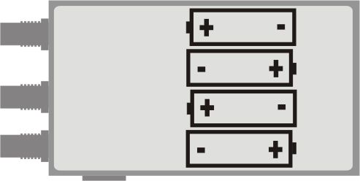
Once the batteries are installed, the unit will power up automatically showing the message “Reset+” on the display and emitting a warning beep; after a few seconds, the unit is ready for operation.
Button functions

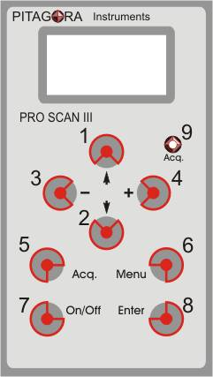
Buttons “1” and “2”, “arrow up” and “arrow down” allow you to scroll the menus.
Buttons “3” and “4”, “minus” and “plus”, allow you to modify data fields or where there is nothing to be modified, you can “enter” or “exit” a menu.
Button “5” or “Acq.” starts the data acquisition at any time.
Button “6” or “Menu” allows you to “enter” or “exit” the “Main menu” and its “submenus”.
“On/Off” button “7” allows you to turn the unit on or off at any time. The “Off” state is actually a standby condition.
Button “8” or “Enter” is used to confirm an operation or choice and also to enter menus.
Position “9” or “Acq.” is a red light LED that flashes during data acquisition.

setting the date and time

Press the “Menu” key to enter the Main menu and use the “UP” and “DOWN” buttons to scroll the main menu until you get to “set time” for the time and “set date” for the date and press “Enter”:
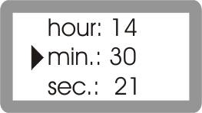
1. set time: the “set time” submenu appears showing the hour on the first line, the minutes (min.) on the second line and seconds (sec.) on the third line. Using the “UP” and “DOWN” arrow buttons you can change from one line to the other, and using the “+” and “-” buttons you can increment o decrement the number or data. Holding the key down, will produce a quicker change in the number.
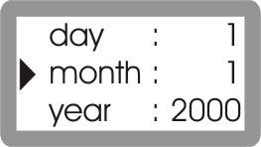
2. set date: the “set date” submenu similar, to the set time menu appears, showing the day, month and year on three subsequent lines. Using the “UP” and “DOWN” arrow buttons you can change from one line to the other, and using the “+” and “-” buttons you can increment o decrement the number or data. Holding the key down, will produce a quicker change in the number.

immediate use as a measurement instrument
Operation

After powering the instrument or when leaving the main menu by pressing the “Menu” or “-” button, ProScan works as a standard measurement instrument.
- Probes
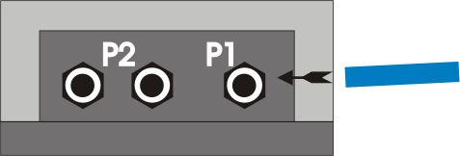
ProScan has three inputs corresponding to its probes (1 for P1 and 2 for P2), which are indicated on top. The P1 input will measure and record absolute pressure, whereas the two P2 inputs will measure and record the differential pressure between the two acquired values on P2. The probes are nothing but standard pneumatic tubes of 2 mm internal diameter and 4 mm external diameter and can be easily inserted by simply pushing the tube into the self locking fitting. In order to remove the tubes from the fittings, press and hold the outermost fitting ring towards the instrument while pulling the tube.

- Auto offset
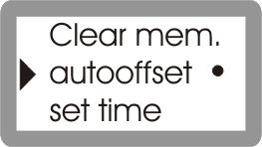
After a prolonged use of the P2 channel, there is the possibility that the internal sensors become slightly deformed, causing an infinitesimal readout error which could alter the data. Activating the “auto offset” option, the instrument will calculate the error during start up and will correct it. In order to enable this option, select it from the Main menu and press “Enter”, blackening the circle on the right of the option.
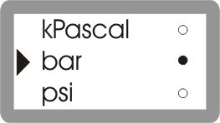
- Units of measurement
ProScan is set to acquire in kPascal, bar, psi, H₂O, Hg, cm. of H₂O and mm. of Hg. The unit to be used can be selected from the Main menu.
Select the desired unit and press “Enter”, the circle on the right will be blackened confirming the change or selection.

Data Acquisition Operation

In order to start the acquisition of pressure data, the user should perform the desired settings.
- Acquisition Rate setting
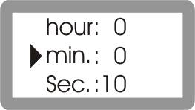
The “acquisition rate” or data acquisition frequency, can be set from the main menu by selecting “acq. rate” and “Enter”. The minimum acquisition rate is 1 second (the instrument will record pressures every second) while the maximum is 1 hour 59 minutes and 59 seconds (the instrument will record every two hours). The data can be changed using the usual “+” or “-” buttons. Once set, “Enter” takes you back to the main menu.
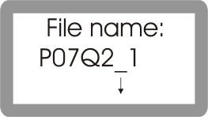
- Starting the Acquisition .
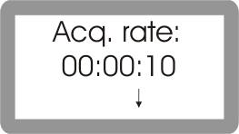
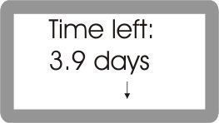
Pressing the “Acq.” button will start data acquisition at any time. Once the “Acq.” button has been pressed, the display will show information such as the filename used for this acquisition data set, (press arrow down for each screen), the acquisition rate, currently chosen, and the amount of memory left (in days or hh/mm/ss) according to the current number of channels and acquisition rate selected, and finally the instrument will request the confirmation whether to start the acquisition or not, pressing “Enter” on “yes” starts the acquisition (the red light or LED starts blinking). If the acquisition rate is not the desired one or there is not enough storage memory, select “no” and you can go back to change the settings.
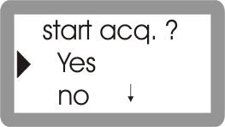
- Information available on the current acquisition
In order to view the current acquisition settings while the instrument is recording, press the “Acq.” Button again. The following information will be displayed, current file name being stored, the acquisition rate, the amount of memory left, and you will be asked to confirm whether you want to stop the acquisition or not. Pressing “Enter” will abandon the menu and continue the acquisition.
- Transferring data to your PC
In order to transfer the data acquired to your PC, or if you wish to perform remote operations from it, the instrument must be connected to the PC using the serial RS-232 communications cable supplied with the Pro Scan. When the unit is connected, a short beep can be heard. The ProScan must be turned on and in the pressure measurement mode (with or without probes). If the instrument is in one of the menus, the communication session will not be started.
- Canceling the memory
In order to cancel the memory contents completely, go down to the “clear mem.” Option on the main menu and press “Enter”. The unit will ask you to confirm, select “yes” and press “Enter” again to confirm. The unit will beep while the whole memory is erased.
WARNING! Once the memory has been cancelled, all data will be definitively lost, there is no possibility to recover it, so please verify that the data has already been transferred or downloaded to the PC.

Display messages

- Low battery!
The batteries are almost discharged and it is highly recommended to replace them. Data accuracy is not guaranteed while the instrument is in this mode of operation.
- Exhausted battery
The batteries are completely discharged and the unit cannot be used in this conditions; please change the batteries.
- Memory full!
The storage memory is full, therefore you cannot start a new acquisition. Please, first download the data previously stored and then cancel the memory.
- Danger overflow
You are trying to measure a pressure that exceeds the maximum pressure allowed, and this could damage the sensors permanently. Warning! Pressure sensor P1 tolerates a maximum overpressure of 30 PSI (2068 mbar or 2 bar), P2 tolerates a maximum over pressure of 150 PSI (10342 mbar or 10.3 bar). Permanent sensor damage will occur if these values are exceeded.

- Acquisition halted!
This message appears when the memory becomes full during the acquisition.
- Reset !
Appears when the unit is turned on for the first time or if there are remote communication problems between the unit and the PC.
- Please Wait !
Appears every time the ProScan is processing data.
- File name:
File name automatically generated by ProScan combining the instrument’s serial number and an additional sequential number..
- Acq. Rate:
Time passed between one acquisition and the next.
- Time left:
Maximum time available for the acquisition calculated according to the remaining memory space, to the number of channels used, and to the acquisition rate.
- Not valid date !!!
An invalid date has been entered.
- Not valid acq. Rate!
The acquisition rate selected is not acceptable.
- ProScan III-2P serial no.
Instrument’s serial number made up of letters and numbers.
- Deleting memory!
This message appears, together with a modulated beeping sound, while the memory is being cancelled.
- Transfer all data!
This message appears, together with a modulated beeping sound, while the data acquired is being transferred to the PC.

Specifications
Electrical

- Measurement range: P1 - absolute pressure (only non corrosive gases) from 0 to 19 PSI (130 K Pascal or 1.3 bar); P2 - differential pressure (only non corrosive gases) from 0 to +/-114 PSI (+/-785 K Pascal or 7.85 bar).
- Resolution: P1 - 0.001 PSI (1 mbar); P2 - 0.01 PSI (0.1 mbar).
- Units: Selectable working units: PSI, in. H2O, in. Hg, KPascal, millibar, cm. H2O, and mm. Hg.
- Accuracy: 0.2 % total error from reading over both channels (linearity and hysteresis error included). *Specified for operating temperatures of 18°C to 28°C (64°F to 82°F).
- Input protection: Warning! Pressure sensor P1 tolerates a maximum overpressure of 30 PSI (2068 mbar). P2 tolerates a maximum over pressure of 150 PSI (10342 mbar).
- Warning! Never apply pressures exceeding the above mentioned limits since this will damage the sensors permanently.
- Reading and Logging rate: from 1 second to 2 hours (setting resolution of 1 second).
- Battery: 4 standard 1.5 V AA alkaline batteries.
- Input connector: super rapid micro fittings
Environmental

- Ambient operating range: -25°C to 70°C
(-13°F to 158°F).
- Storage temperature: -40°C to 80°C
(-40°F to 176°F).
- Humidity: 0% to 90% (0°C to 35°C / 32°F to 95°F). 0% to 70% (0°C to 50°C / 95°F to 122°F).

Physical

- External dimensions:
150 mm. x 84 mm. x 45 mm.
- Ingress protection: IP40/DIN VDE 0470.
- Weight: 350 grams.(12.5 oz).
Disclaimer

During normal operation and proper use of the ProScan instruments, it is quite improbable for the data acquired to be lost. However, Pitagora S.A. declines any responsibility for the loss or corruption of data due to improper use, malfunctioning, hardware defects or for any other cause.

Pitagora S.A. reserves the right to modify the contents of this manual at any time and without prior notice.

